**VIDEOS**

ACTIVITY 1 : TABLEAU - MYSQL CONNECTION

<https://drive.google.com/file/d/1dwuuc28u1bthHq7WzxRGOgckgCYOTuAF/view?usp=sharing>

ACTIVITY 2 : TEXT TABLE

<https://drive.google.com/file/d/172F-SohRdN2TuSH4SuLnLtSdmxn0us9F/view?usp=sharing>

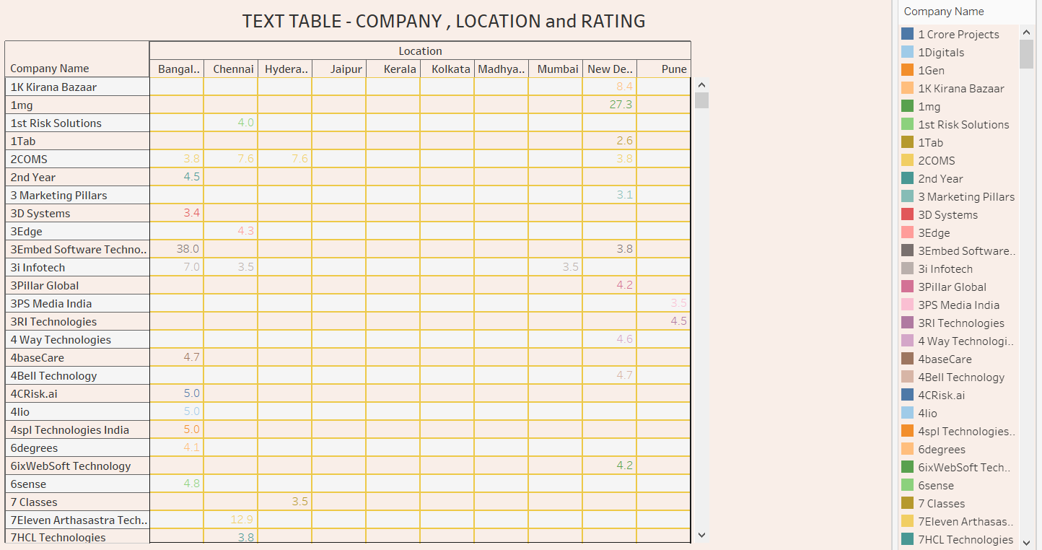

ACTIVITY 3 : TREE MAP

<https://drive.google.com/file/d/1Wk8iuLvbBT7mxk7TDWPkXUBorFndDx4b/view?usp=sharing>

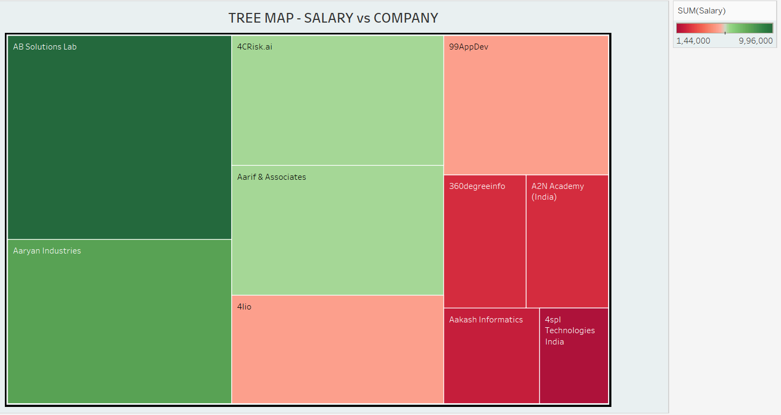

ACTIVITY 4 : BOX PLOT

<https://drive.google.com/file/d/1Iw7XccRuVV_IUBYLKMHJNmUY8JBoFTPF/view?usp=sharing>

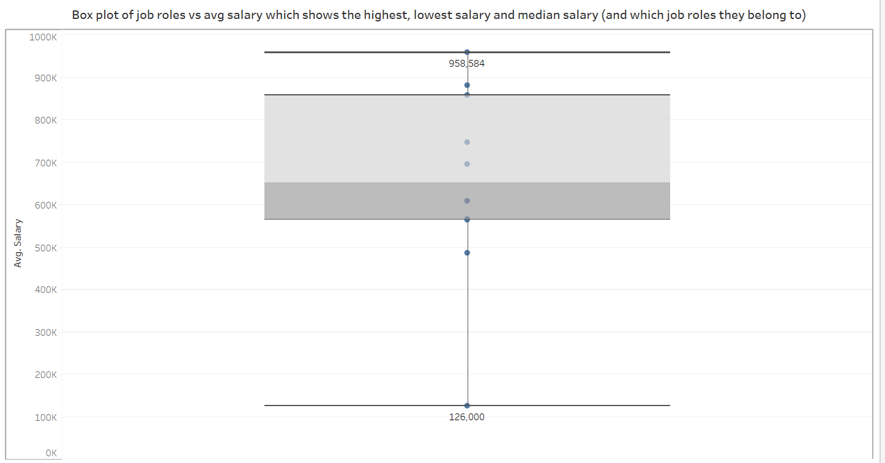

ACTIVITY 5 : MAP

<https://drive.google.com/file/d/1IxTLSoyiUTCHVIdUXTAho1hB2oTJE-Cz/view?usp=sharing>

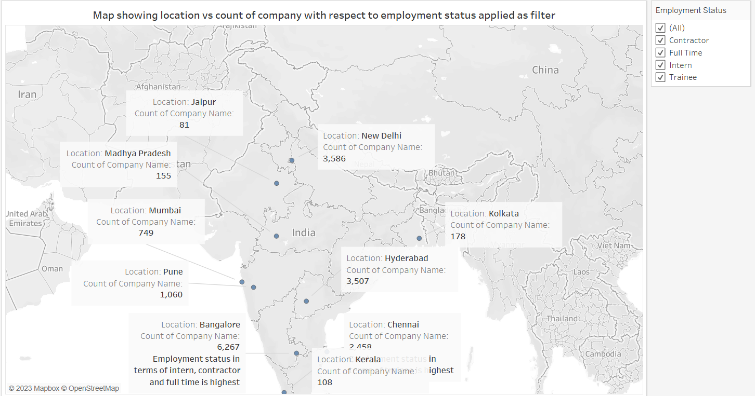

ACTIVITY 6 : BAR GRAPH

<https://drive.google.com/file/d/1ts-ZOu351CiUCZyfiLtaVtJ55l74yeCV/view?usp=sharing>

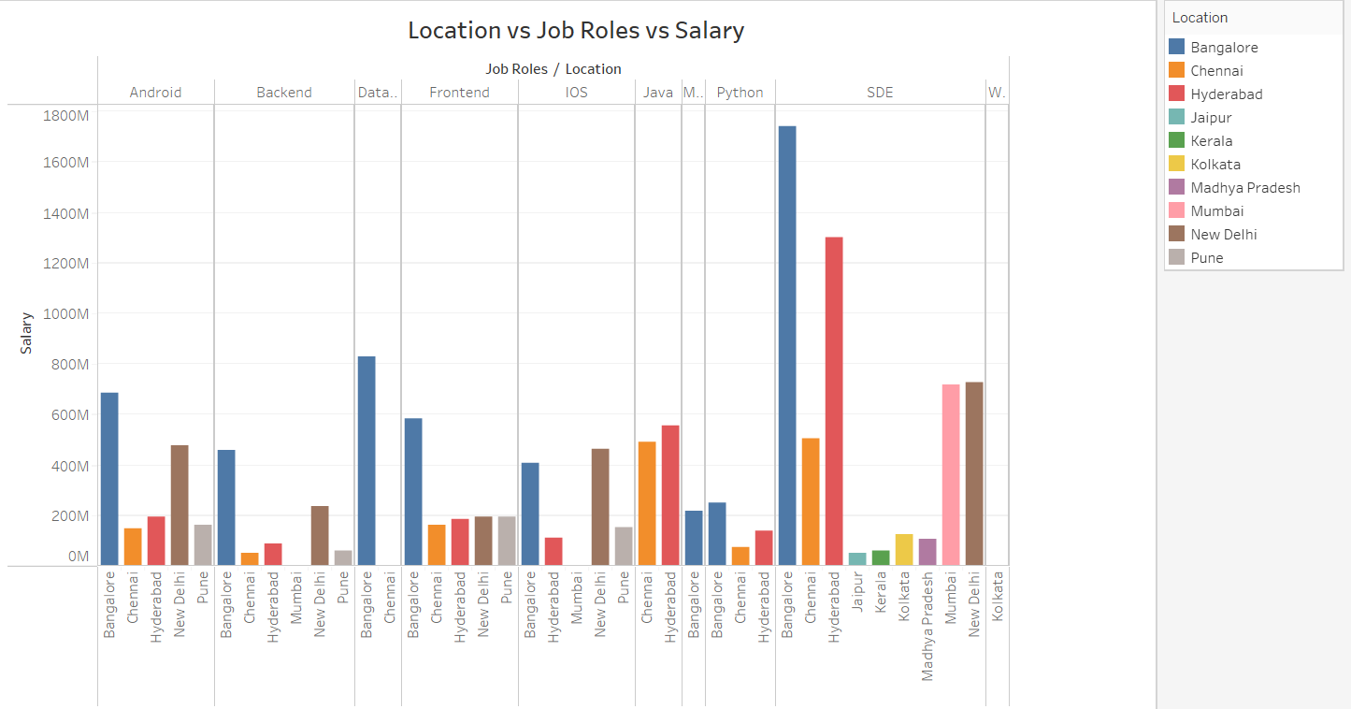

ACTIVITY 7 : PIE CHART

<https://drive.google.com/file/d/185MJzGe3h4fl1uACYe8A-uhhkqorKFvp/view?usp=sharing>

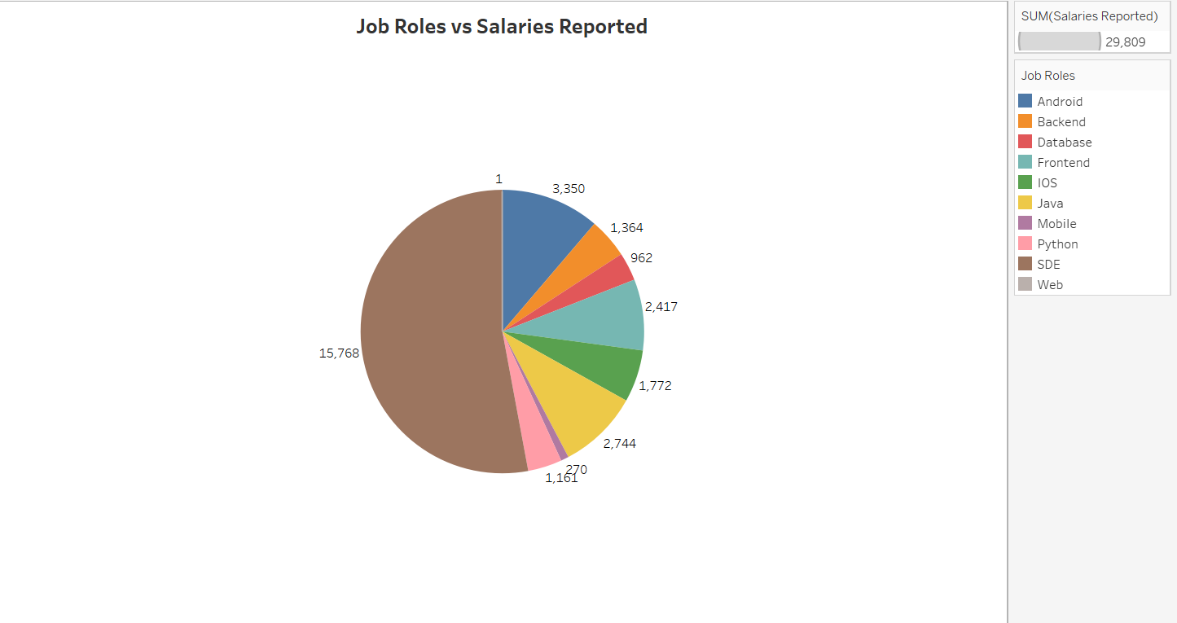

ACTIVITY 8 : DOUGHNUT CHART   
<https://drive.google.com/file/d/1bHfiuIVZuUj8pZryNQ481fVJzuMuLR5x/view?usp=sharing>

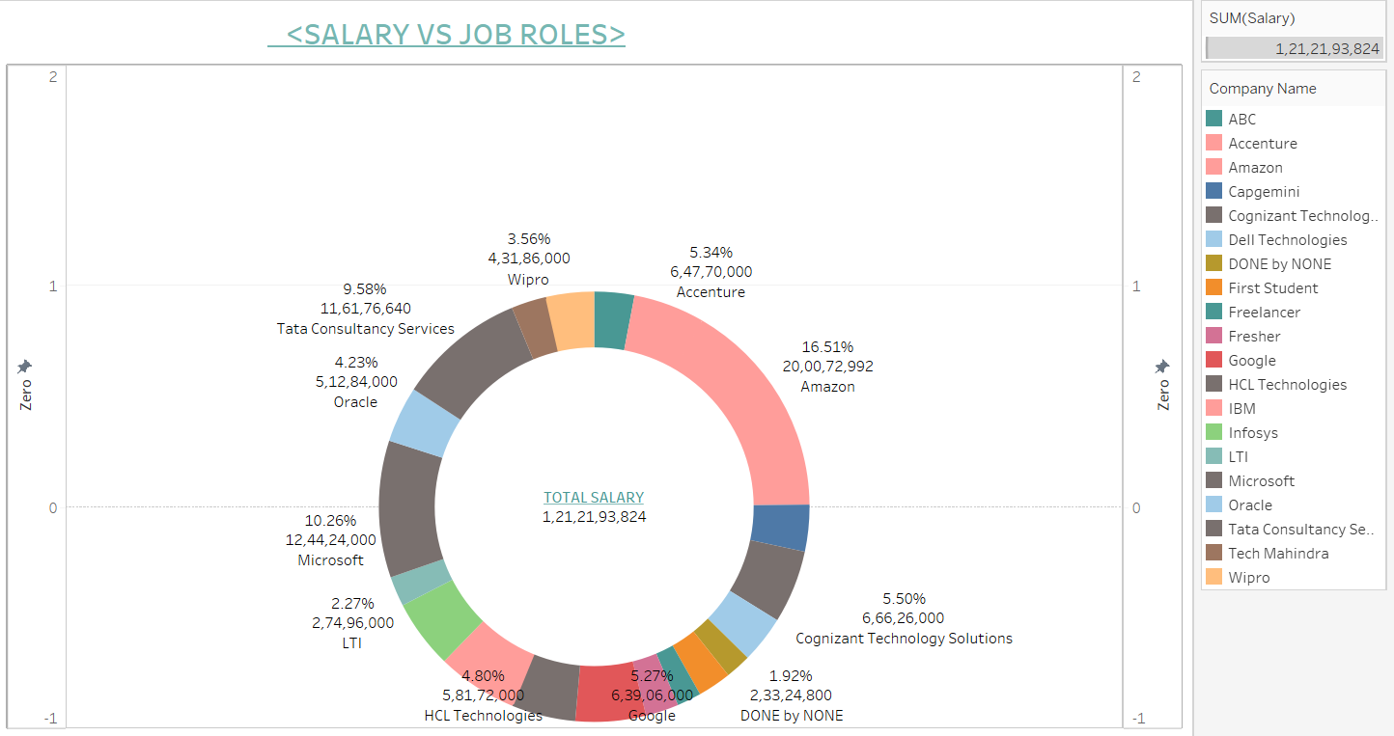

ACTIVITY 9 : HEAT MAP

[HEAT MAP(project_it_sector_salary_job_roles).mp4](https://drive.google.com/file/d/1aNvRT7zagiXXflrJUGiu0tcJztHtX9zY/view?usp=sharing)

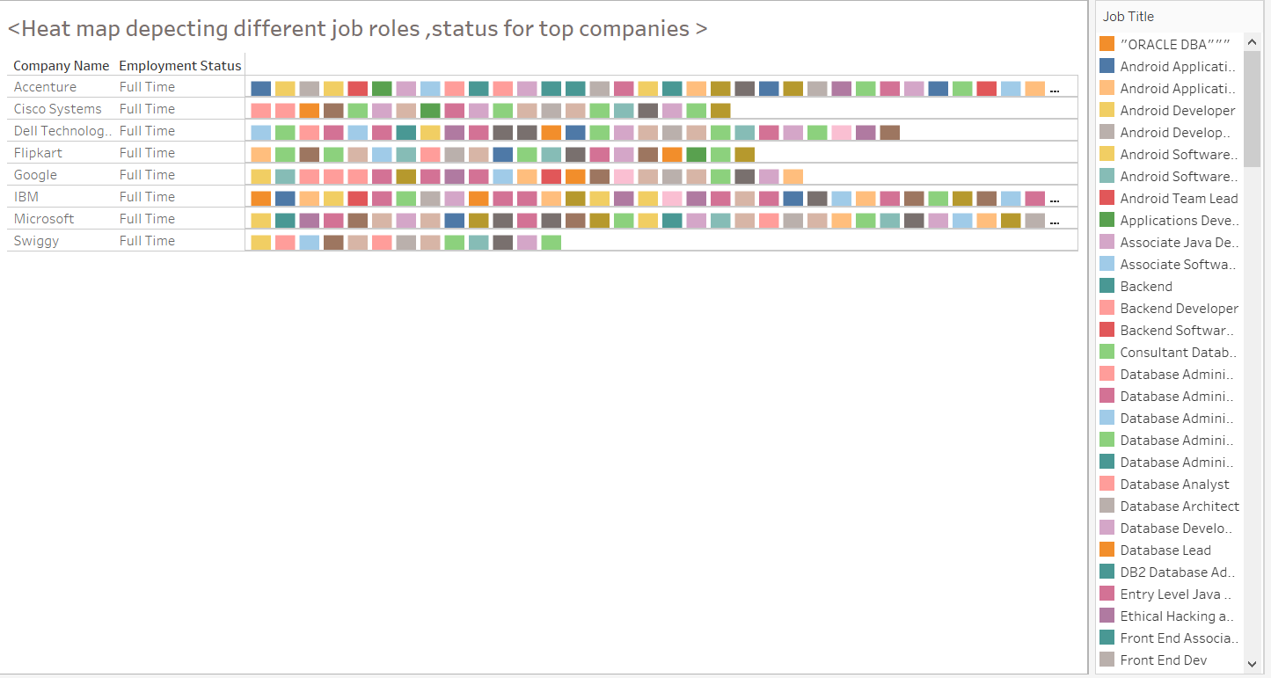

ACTIVITY 10 : DASHBOARD

<https://drive.google.com/file/d/1_BfjWKV7huhdJ813dfUI9gWxeY-dfzJh/view?usp=sharing>

DASHBOARD 1 :

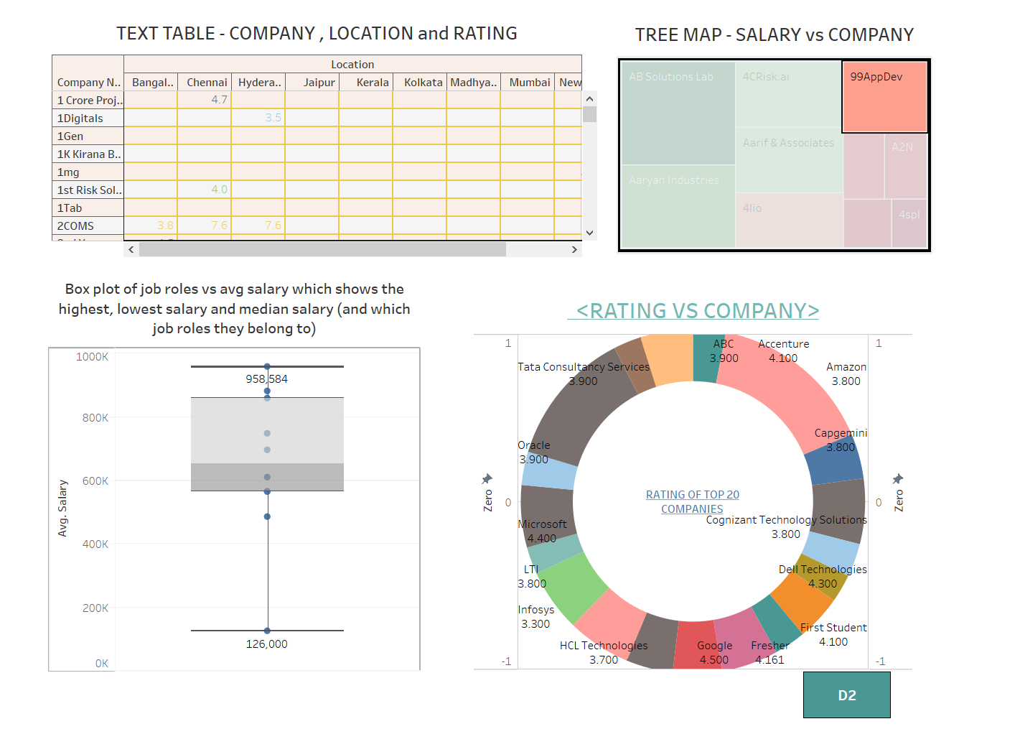

DASHBOARD 2 :

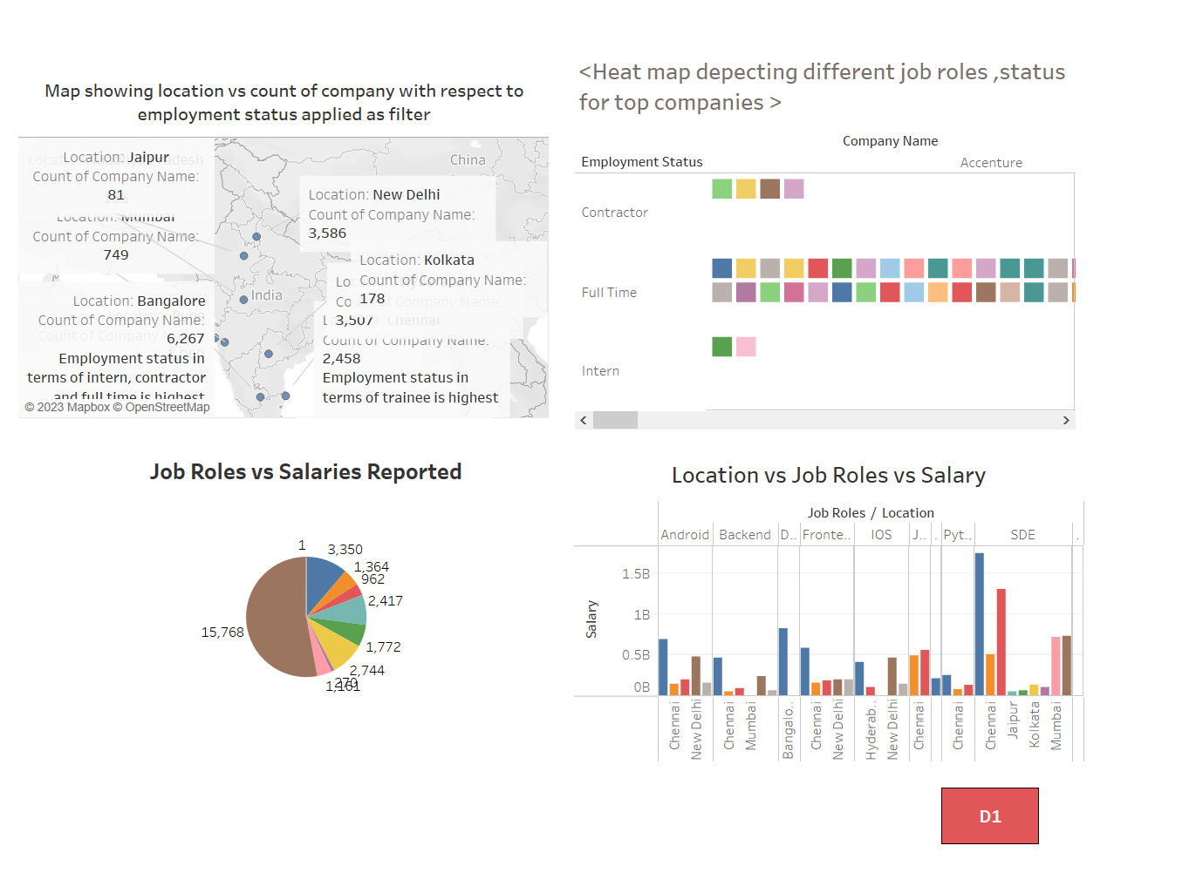

ACTIVITY 11 : STORY

[STORY(project_it_sector_salary_job_roles).mp4](https://drive.google.com/file/d/1gFNDWZhMLznXNGCvG6aRc0vYdb0vyXWx/view?usp=sharing)

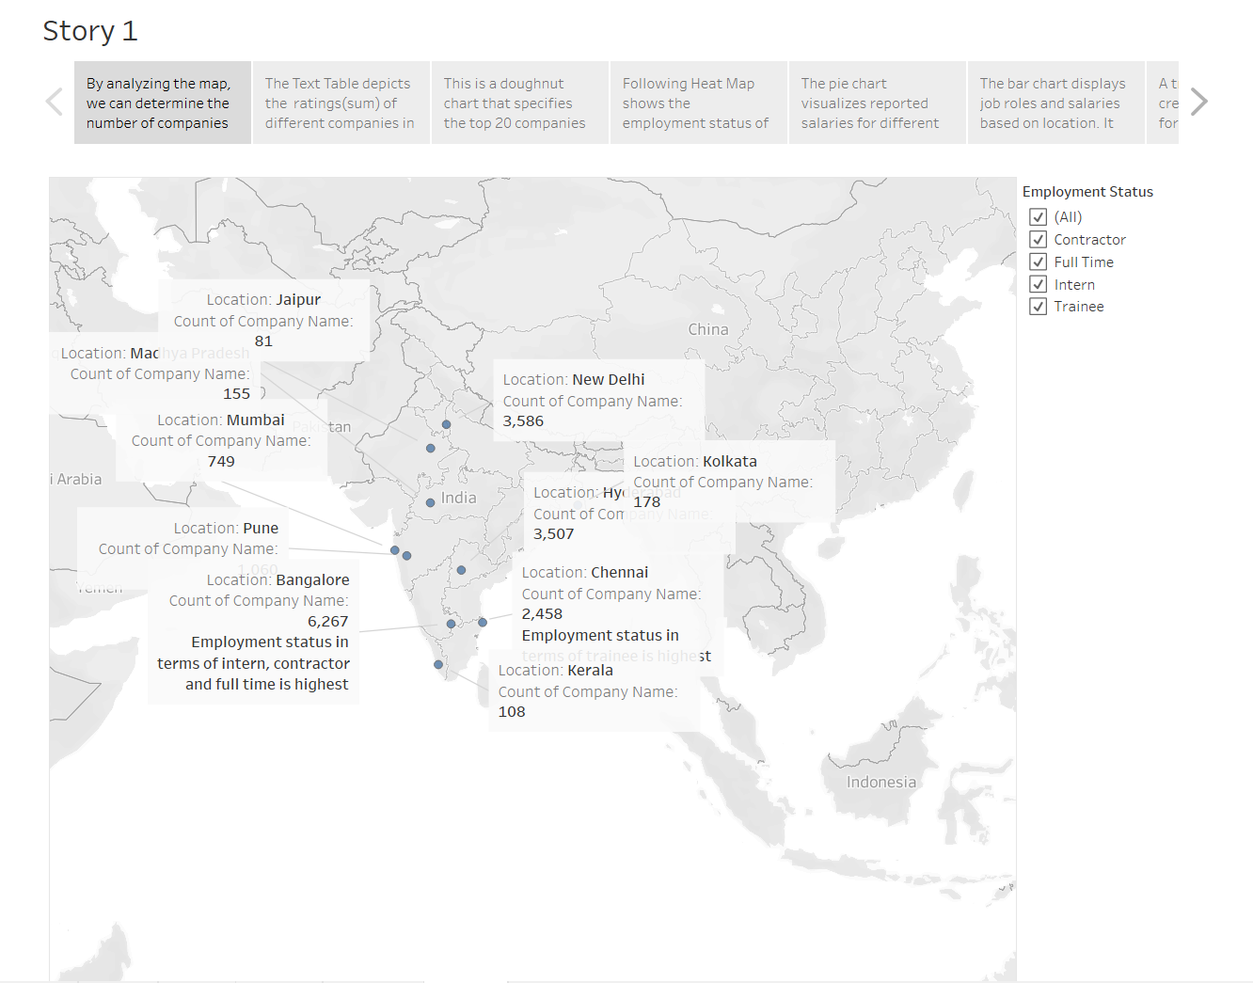

ACTIVITY 12 : TABLEAU PUBLIC SERVER UPLOAD :

<https://drive.google.com/file/d/1duYQt3ZQ3p1sHIthEEXzpfKaOe3oPQD2/view?usp=drive_link>

<https://drive.google.com/file/d/14dpNw6_TDfrZcmhB_2pHygKxKyUm1nAe/view?usp=sharing>

<https://public.tableau.com/views/D1_16877637365240/D1?:language=en-US&publish=yes&:display_count=n&:origin=viz_share_link>

<https://public.tableau.com/views/D2_16877637856380/D2?:language=en-US&publish=yes&:display_count=n&:origin=viz_share_link>

<https://public.tableau.com/views/StoryITSectorDtaset/Story1?:language=en-US&publish=yes&:display_count=n&:origin=viz_share_link>

ACTIVITY 13 : WEB INTEGRATION

<https://drive.google.com/file/d/1_AjwMrlNIwgW997P3qdJ-Bb6Q0VwDhay/view?usp=sharing>

ACTIVITY 14 : FLASK DEPLOYMENT

<https://drive.google.com/file/d/19GL8VWS7OiyObklywi2enaX7r8BRrorv/view?usp=sharing>